- Identify a source or range of experiences to investigate, e.g. the editorial page, a political speech, a pop science source, rumors on the playground.
- Students look there for “red lights” and “yellow lights,”specific moments with signs of a possible puzzle of truth, like sweeping generalizations, blatant self-interest.
- Round up students’ observations. Make a list of specific points marked R for red or Y for yellow with the sign (see sample chart). Also, ask students to identify “red zones” and “yellow zones,” whole areas that tend to be full of red or yellow lights. Write them on the board in circles.
- Ask: What have we learned about particular signs that there could be a problem of truth? What have we learned about zones to watch out for?
Red light, Yellow light only identifies potential issues of truth. You may want to go on to some other truth routines to dig into a couple of the issues.

Purpose: What kind of thinking does this routine encourage?
In the general clutter of everyday life, moments that need deeper thinking tend to be invisible. Students have to learn to see them. This routine focuses students on signs of puz-zles of truth, and also on typical red zones and yellow zones where such puzzles are common. To build up this sensitivity, use the routine often in deliberately different ways.
Application: When and Where can it be used?
Wherever there might be interesting puzzles of truth: a text that might have questionable claims, the daily paper, TV news, political speeches, a mystery story, a math proof that might have weaknesses, playground activities and conversations, home life, pop science, potentially risky behaviors, self-critique of something one has written, etc. For settings outside of school, students can keep logs over a day to a week. Typical red zones are the editorial pages of newspapers, political speeches, playground arguments, because so many red lights occur within them.
The source should be large enough to take some time, like a chapter or keeping track of rumors for a few days. That way, students have to keep alert in a sustained way, which practices their skills of noticing puzzles of truth.
Launch: What are some tips for starting and using this routine?
Explain that “red lights” are specific moments with signs of a possible puzzle of truth, signs like sweeping statements, one-sided arguments, obvious self-interest, etc. See the sample chart for others. Yellow lights are milder versions of the same thing.
Naturally students may disagree on what’s red vs. yellow vs. green in particular cases. Have students explain the signs and their judgments briefly, but mainly the routine is for detectingpotential puzzles of truth. The real way to investigate a couple of the more important red or yellow lights is to dig further into the issue with another truth routine.
List of some signs to start with. Students can add to this.
Red Lights/Yellow lights for problems of truth
Sweeping generalization
One-sided arguments
Bold claim, no argument
Blatant self-interest
Extreme conviction
No obvious expertise
Angry claims
Feelings: seems implausible, uncertain, tentative
Plainly an opinion
Students investigating a newspaper might find examples (abbreviated) like these
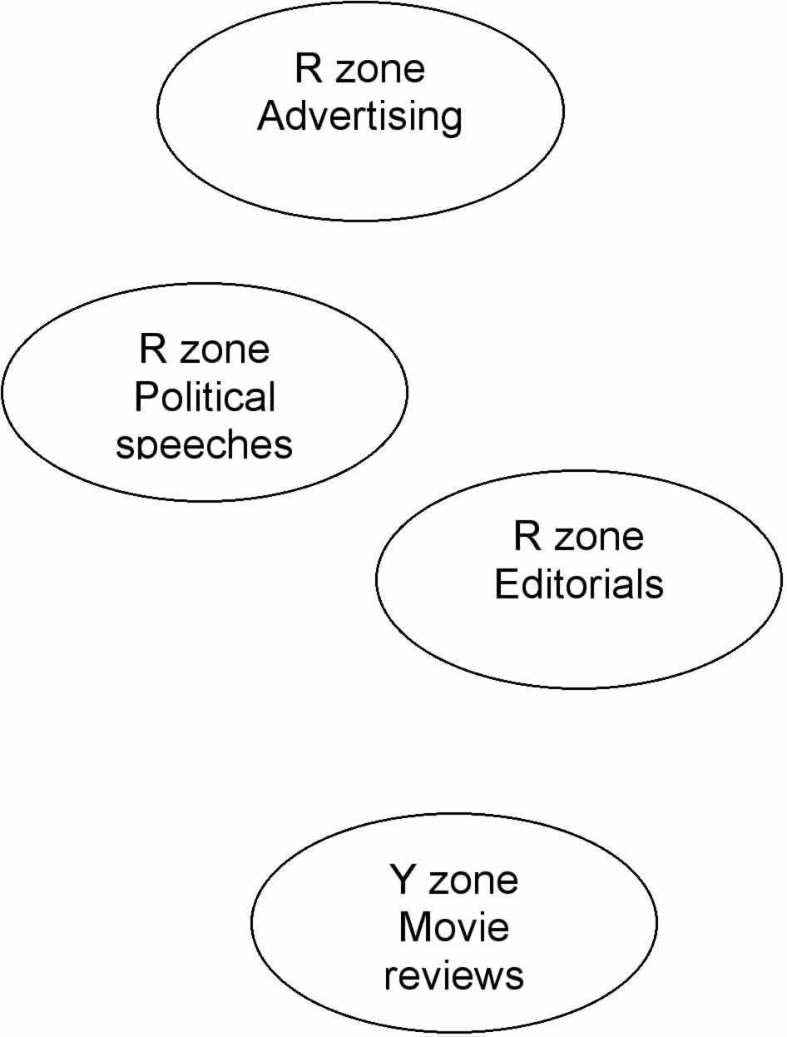
R The only honorable way out is to win on the battlefield (political, extreme statement, no argument)
Y The majority of people agree… (evidence?)
R I’m sick and tired of the way…. (editorial, angry claim)
Y The senator expressed his judgment that… (tentative)
R You can save more now than ever before… (ad, blatant self-interest)
Y Thousands of people flock to these kinds of self-medication (re the medications, lack of expertise)
Y Both teenagers and young adults will like this film (opinion)

